

Korea Lunar Exploration Program
DTNPL Mass Properties Report

Date: 29 Oct. 2018 | Doc. No: KPLO-D0-550-101  Issue: 1.0  Total page: 15

Superseding Revised

Prepared By:

Jeong-Chan Lee Date
DTN SBC Mechanical Engineer, Lumir

Reviewed By:  Chang-Soo Lee Date  DTN SBC Product Assurance, Lumir |  | Dae-Soo Oh Date  DTN SBC Project Manager, Lumir
Kyung-Rak Lee Date
DTN Payload Engineer, ETRI

Approval Signature:  Choel-Oh Jeong Date  DTN Payload Product Assurance, ETRI |  | Jin-Ho Jo Date  DTN Payload Project Leader, ETRI

Original CDMO Release__________________

Revision History
Version | Author(s) |  | Date | Description
0.1 | Jeong-Chan Lee |  | 2017. 12. 28 | Draft
1.0 | Jeong-Chan Lee |  | 2018. 10. 29 | Final

Revision/Change Records
Version | Date | Revision/Change Description | Pages
0.1 | 2017. 12. 28 | Initial | All
1.0 | 2018. 10. 29 | Final | All

Documents Tree

Contents

1. Introduction 8
1.1. Purpose and Scope 8
1.2. Applicable Documents 8
1.2.1. ETRI Documents 8
1.2.2. Other Documents 8
1.3. Abbreviations 8
2. Operation Description 9
2.1. DTN and Space Communications 9
2.2. Mission of DTN Operation 9
2.3. DTN Configurations 9
2.4. Communication Nodes 10
2.4.1. DTN nodes 10
2.4.2. Non-DTN nodes 10
3. System Configuration of DTN Payload 11
4. Mass Property 12
4.1. Mechnical Configuration 12
4.2. Mechanical Interface 13
4.3. Mass Budget 13
4.4. Center of gravity 14
4.5. Moment of inertia 15

Figures

Figure 2-1 DTN test configuration in the first phase 10
Figure 3-1 Interface diagram of DTN payload 11
Figure 3 Mechanical Configuration 12
Figure 4 exploded configuration 12
Figure 5 DTN PL interface design 13
Figure 6 Center of gravity 14

Tables

Table 1 Mass Budjet 13
Table 2 Center of gravity 14
Table 3 Moment of Inertia 15

Introduction

Purpose and Scope
This document describes the system specifications of DTN payload for Korea lunar exploration program.

Applicable Documents

ETRI Documents
Document Number | Document Title
KPLO-D0-551-002 | Operation Scenario of DTN
KPLO-D0-550-000 | System Requirements of DTN Payload

Other Documents
Document Number | Document Title
KPLO-SP-300-002 | KPLO System Requirements Document

Abbreviations
AMS | Asynchronous Message Service
AOS | Advanced Orbiting System
BP | Bundle Protocol
BSS | Bundle Streaming Service
CCSDS | Consultative Committee for Space Data Systems
CFDP | CCSDS File Delivery Protocol
DCC | DTN Control Center
DTN | Delay(Disruption) Tolerant Network
DTNPL | DTN Payload
IP | Internet Protocol
KPLO | Korea Pathfinder Lunar Orbiter
LCM | Lander Communication Model
LTP | Licklider Transmission Protocol
M&C | Monitor & Control
RCM | Rover Communication Model
SLE | Space Link Extension
TBC | To Be Confirmed
TBD | To Be Defined
TCP | Transmission Control Protocol
UDP | User Datagram Protocol

Operation Description

DTN and Space Communications
Delay/disruption tolerant networking (DTN) technology offers a new solution to highly stressed communications in space environments, especially those with long link delay and frequent link disruptions in deep space missions. Delay/disruption tolerant networking (DTN) technology offers a new solution that use a store-and-forward mechanism to combat long link delay and frequent link disruptions generally characterizing space communications. DTN communications use a bundle protocol (BP), to construct a store-and-forward overlay network. The BP, situated at the application layer of the Internet model, utilizes conventional Internet protocols to send and receive data bundles. The benefits of DTN communications are as follows.
- Interoperability and Reuse: A standardized DTN protocol suite enables interoperability of multi-agency communication assets and also allows NASA to use the same communication stack for future missions (LEO, NEO or Deep Space).
- Space Link Efficiency, Utilization and Robustness: DTN enables more reliable and efficient data transmissions resulting in more usable bandwidth. DTN also improves link reliability by having multiple network paths and assets for potential communication hops.
- Security: The DTN Bundle Security Protocol (BSP) allows for integrity checks, authentication and encryption, even on links where not previously used.
- Quality of Service: The DTN protocol suite allows for many priority levels to be set for different data types, ensuring that the most important data is received ahead of less important data.
- Improved Operations and Situational Awareness: The DTN store-and-forward mechanism along with automatic retransmission provides more insight into events during communication outages and significantly reduces the need for ground-based scheduling.

Mission of DTN Operation
The mission of DTN is to validate DTN communication protocols by space link testing through KPLO. So DTN operations are focused on testing the DTN protocols using KPLO space links.

DTN Configurations
In the first phase of lunar exploration, test lunar orbiter called Korea Pathfinder Lunar Orbiter (KPLO) will be launched without lunar lander. Figure 2.1 shows DTN configuration in first phase of lunar exploration. There are no Lander and Rover on the moon in first phase. So Lander Communication Mode (LCM) and Rover Communication Mode (RCM) will be located on earth for the DTN communication testing.
DTN Payload (DTNPL) is a DTN node in the space. DTNPL will be mounted on the KPLO for DTN communication. DTN Control Center (DCC) is a control center of DTN communication nodes. LCM and RCM are DTN nodes on ground. All DTN nodes on ground are interconnected by the terrestrial network such as Internet. MCC and DSN are not DTN nodes. They just transfer DTN packets to next communication nodes.

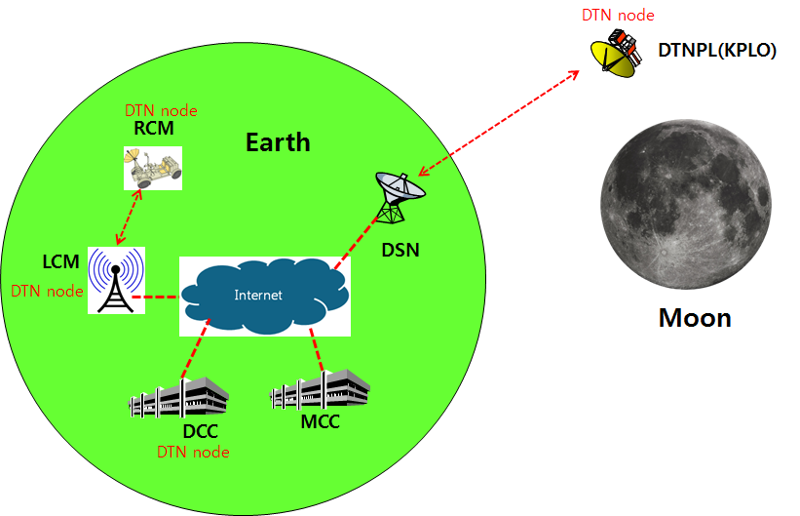
Figure 2-1 DTN test configuration in the first phase

Communication Nodes
Many communication nodes are needed for the DTN operation. Some of communication nodes in the network are DTN nodes whereas otherwise nodes are non-DTN nodes. The function of communication nodes used in the DTN operation is as follows.

DTN nodes
- DCC is a ground DTN node which monitor and controls DTN nodes. DCC send commands to DTN nodes such as DTNPL, LCM and RCM. It also receives telemetries or acquired data from some DTN nodes such as RCM or LCM.
- DTNPL is a DTN node mounted on the KPLO. DTNPL can be operated as a DTN end point. And it also can be operated as relay nodes which relay DTN data between DCC and RCM or LCM.
- LCM is a ground DTN node. LCM relays DTN data between MCC and RCM.
- RCM is a ground DTN node and a DTN end point. The commands sent by the DCC is terminated at the RCM and the RCM returns telemetry or data to DCC through KPLO.

Non-DTN nodes
- MCC is a non-DTN node. MCC monitors and controls KPLO and payloads. MCC also receives and processes data generated from the payloads and transfers to each payload control center.
- DSN is a ground station for deep space communication. DSN will have a big size of antenna and RF equipment for space link interface. DSN also have network equipment for terrestrial communication interface such as SLE link. DSN is a non-DTN node.

System Configuration of DTN Payload

The DTN payload shall have interface with KPLO for the operational power supply and for the communications. The following figure shows DTN payload interface diagram with KPLO.

Figure 3-1 Interface diagram of DTN payload

There are four kinds of interface types between DTNPL and KPLO. Each interface types are described as following.
- TM/TC (bi-level): One bi-level TC and one bi-level TM for DTNPL emergency operation.
- Bi-level TC: System reset command in the emergence condition
- Bi-level TM: Telemetry showing that DTNPL is in alive
- TM/TC (UART): Serial communication channel for TM/TC communication with KPLO OBC
- Data downlink [TBD]: Serial data downlink channel to KPLO PDHU
- Power: Operation DC power +28V from the KPLO PCDU

Mass Property

Mechnical Configuration
DTN PL consisted of 1 PCB modules, 1 Motherboard, 1 Top Cover.
Total Mass: 0.89±2% kg
Dimension: W x L x H = 120 x 170 x 39 mm

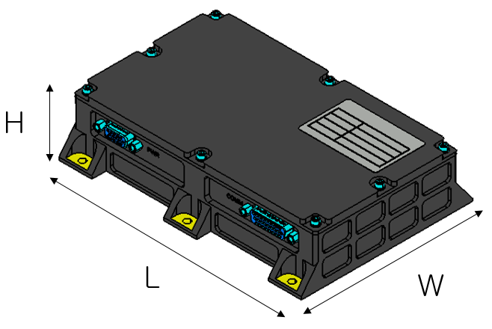
Figure 3 Mechanical Configuration

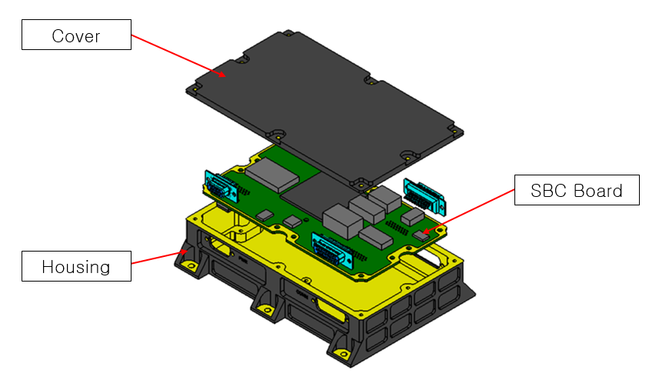
Figure 4 exploded configuration

Mechanical Interface
The DTN PL is fixed 6 holes by M4 bolts on spacecraft
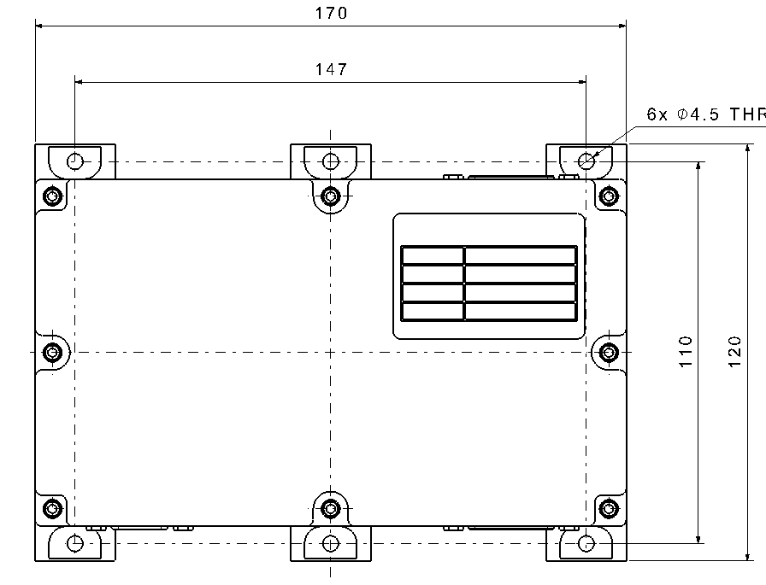
Figure 5 DTN PL interface design

Mass Budget

Table 1 Mass Budget
Name | Mass [kg] | Remark
Housing | 0.37 | Measured weight
Top Cover | 0.23 | Measured weight
SBC PCB+EEE Parts | 0.15 | Measured weight
etc (bolts, bonding, coating) | 0.14
Sum | 0.89 | Requirement: < 2 kg

Center of gravity
Center of gravity is shown in the following figure and table.
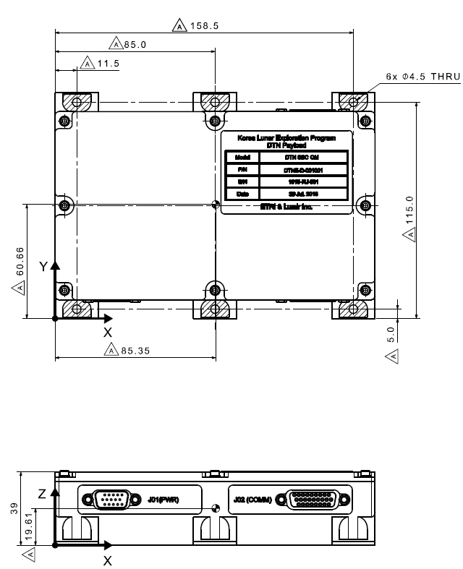
Figure 6 Center of gravity

Table 2 Center of gravity
Axis | Location
X | 85.35
Y | 60.66
Z | 19.61

Moment of inertia
Moment of inertia is shown in the following table.

Table 3 Moment of Inertia
Moment of inertia
I_{xx} [ ${kg-m}^{2}$ ] | 0.004
I_{yy} [ ${kg-m}^{2}$ ] | 0.008
I_{zz} [ ${kg-m}^{2}$ ] | 0.011
I_{xy} [ ${kg-m}^{2}$ ] | -0.004
I_{yz} [ ${kg-m}^{2}$ ] | -0.001
I_{xz} [ ${kg-m}^{2}$ ] | -0.00874

